**Assignment – 7**

1. Write a C program to read numbers from a file and write even, odd and prime numbers to separate file.

**Code:**

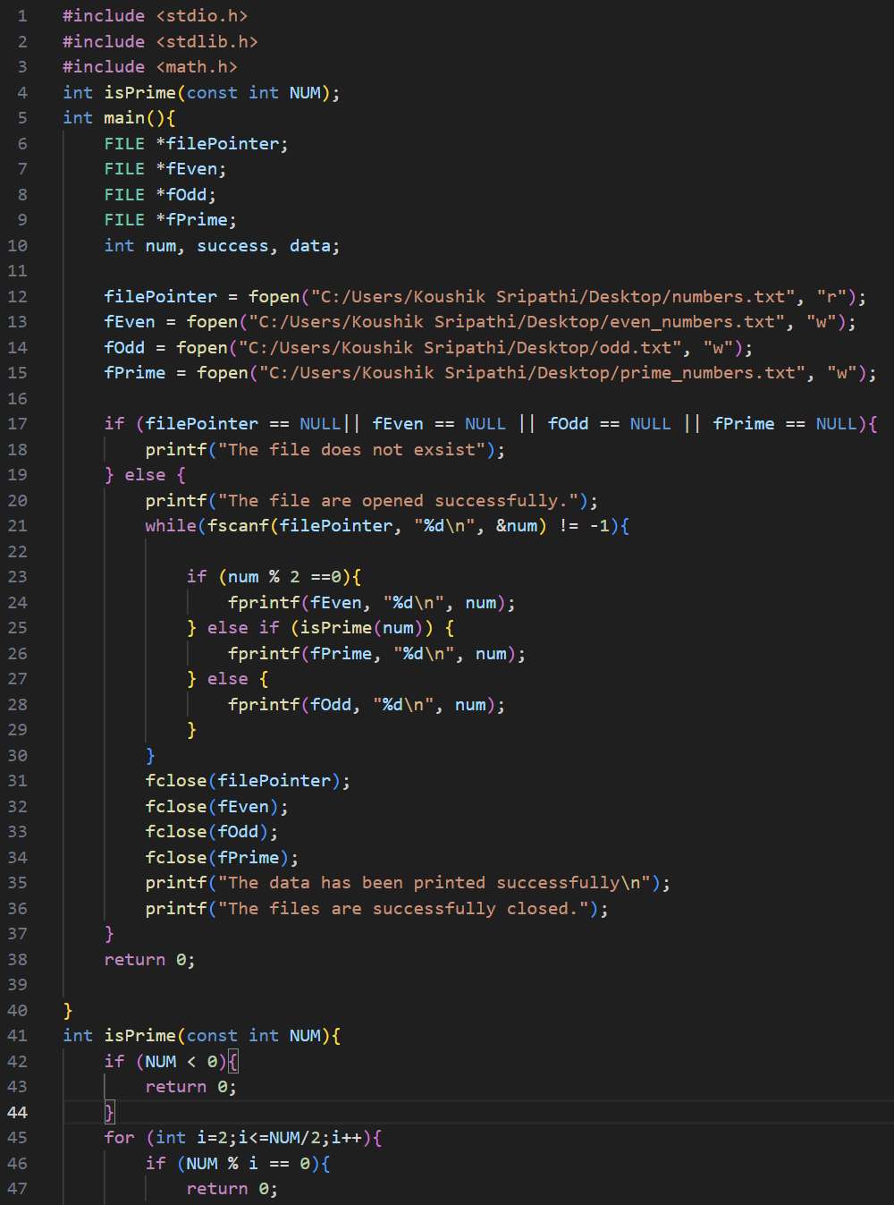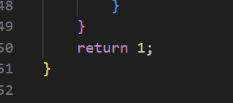

**Output**



**Input file**

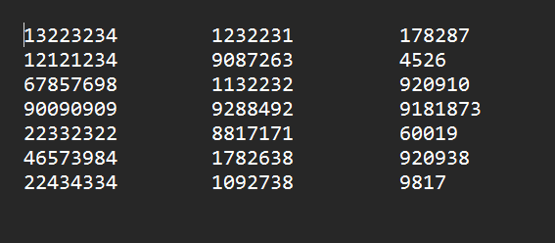

**Output files**

1. **Odd numbers**

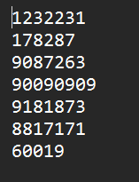

1. **Even numbers**

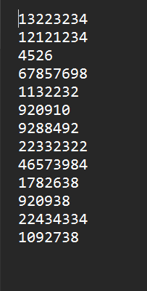

1. **Prime numbers**



1. Write a C program to merge two files to third file.

**Code:**

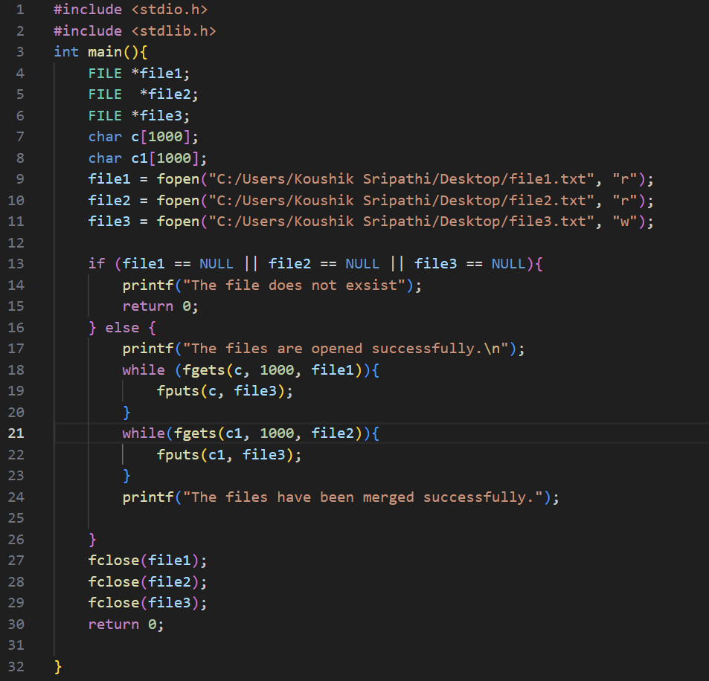

**Output**



**Intput files**

**File1**



**File2**



**Output file**

**File3**



1. Write a C program to count characters, words and lines in a text file.

**Code:**

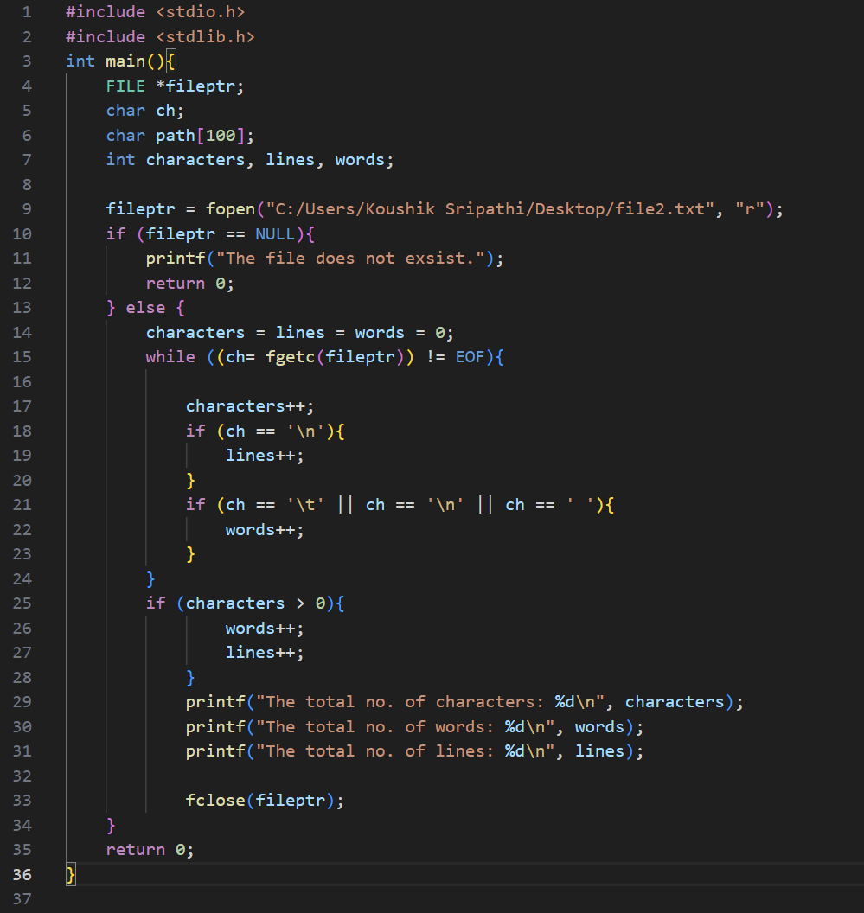

**OUTPUT**

**Input file**



**Given output**

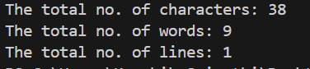

1. Write a C program to convert uppercase to lowercase character and vice versa in a text file.

**Code:**

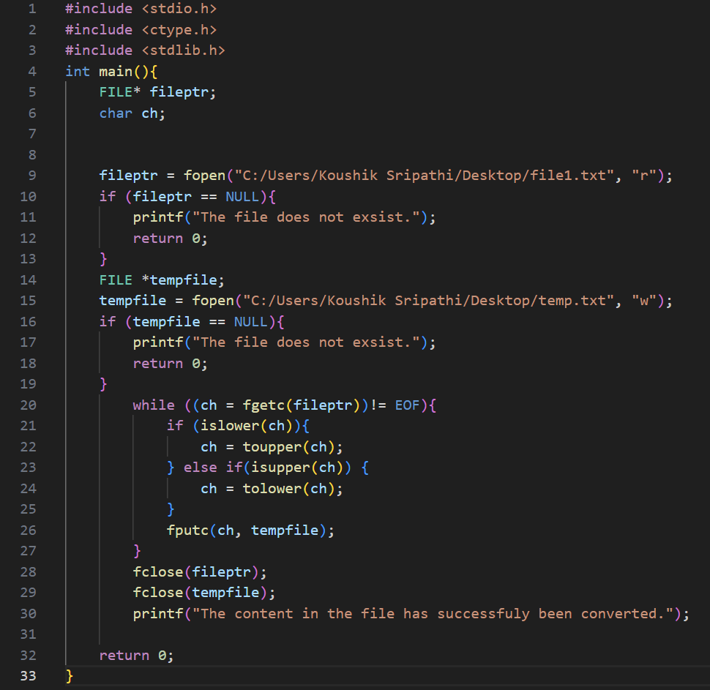

**OUTPUT**



**Input file**



**Output file**

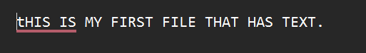

1. Write a C program to copy contents from one file to another file.

**Code:**

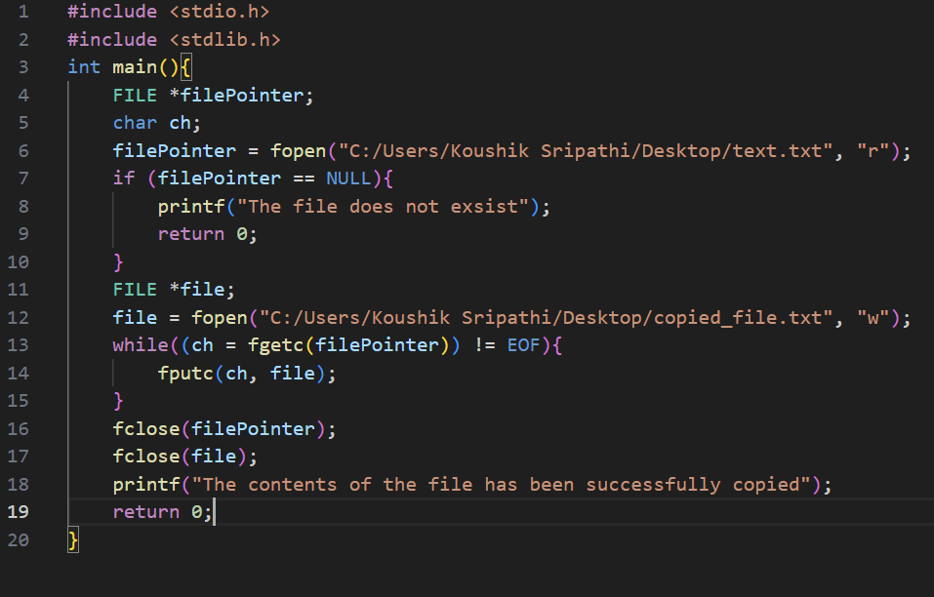

**Output**



**Input file**



**Output file**

